Step 1: launching instance with linux server

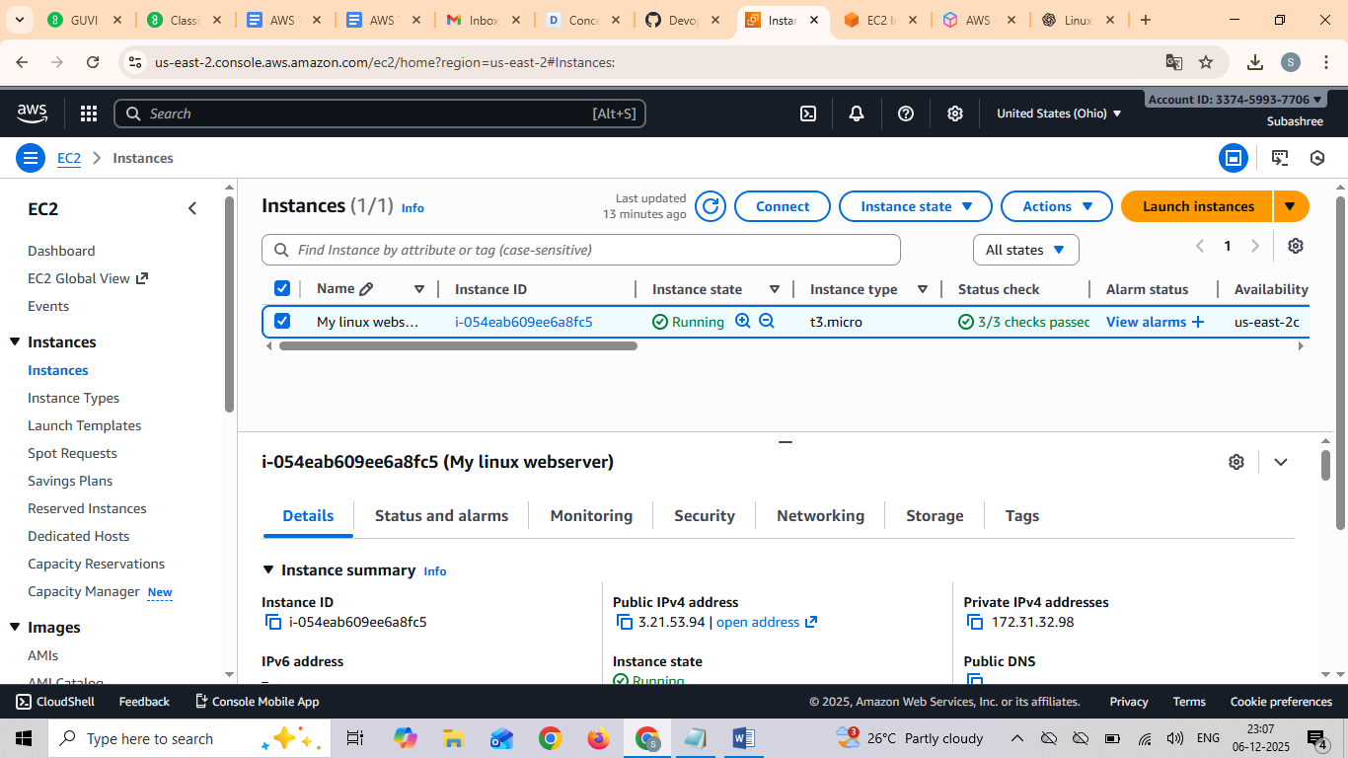



Comments used in linux
Sudo su –
Yum update –y
Yum install –y httpd
Systemctl start httpd
Systemctl status httpd
Systemctl enable httpd
echo "Welcome to the linux server" > /var/www/html/index.html

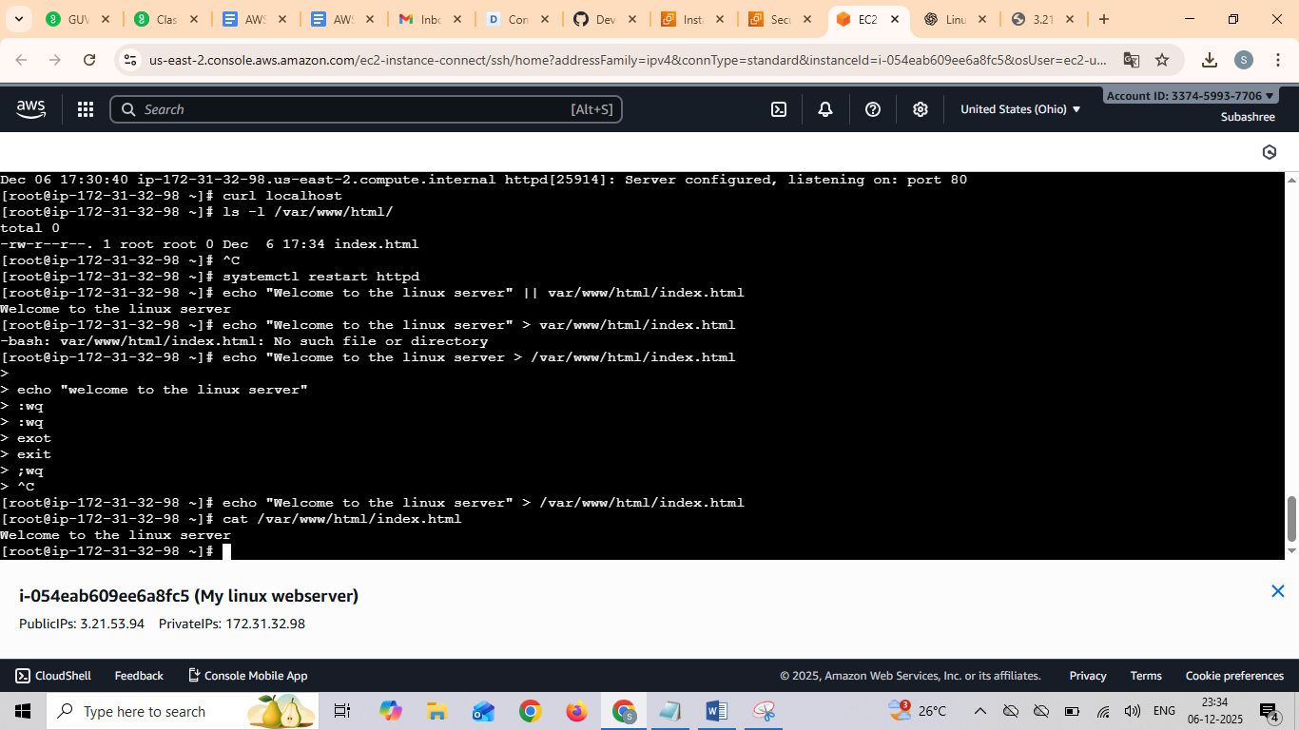

Step 2:
Windows instance
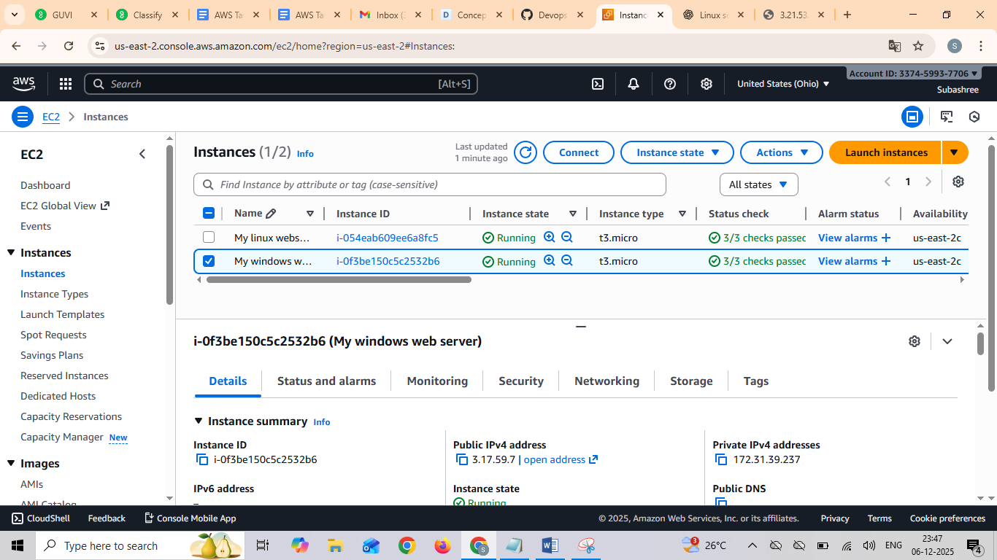

Launched windows and connected with rdp client
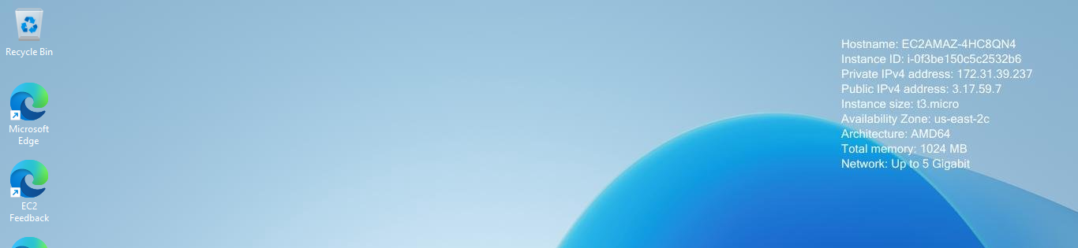

Inside windowns RDP

Server manager ---- add roles – next ---- select webserver iis – next and finish
After enabled IIS
Checked in chrome with public IP 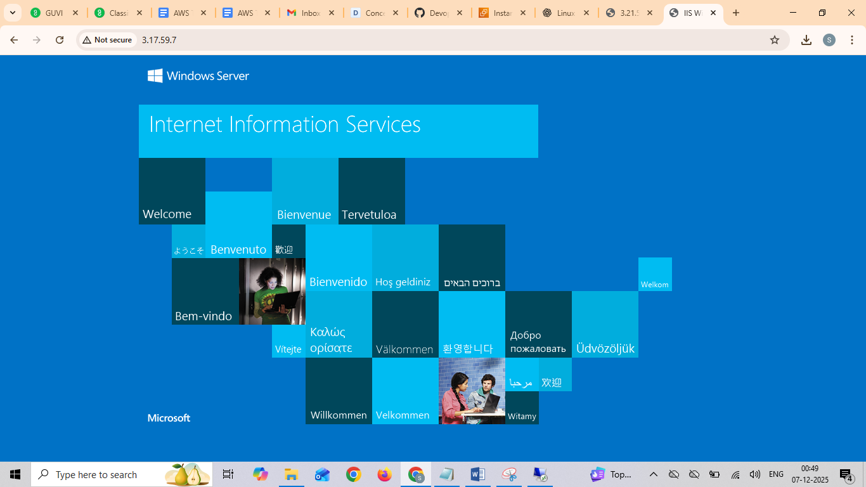

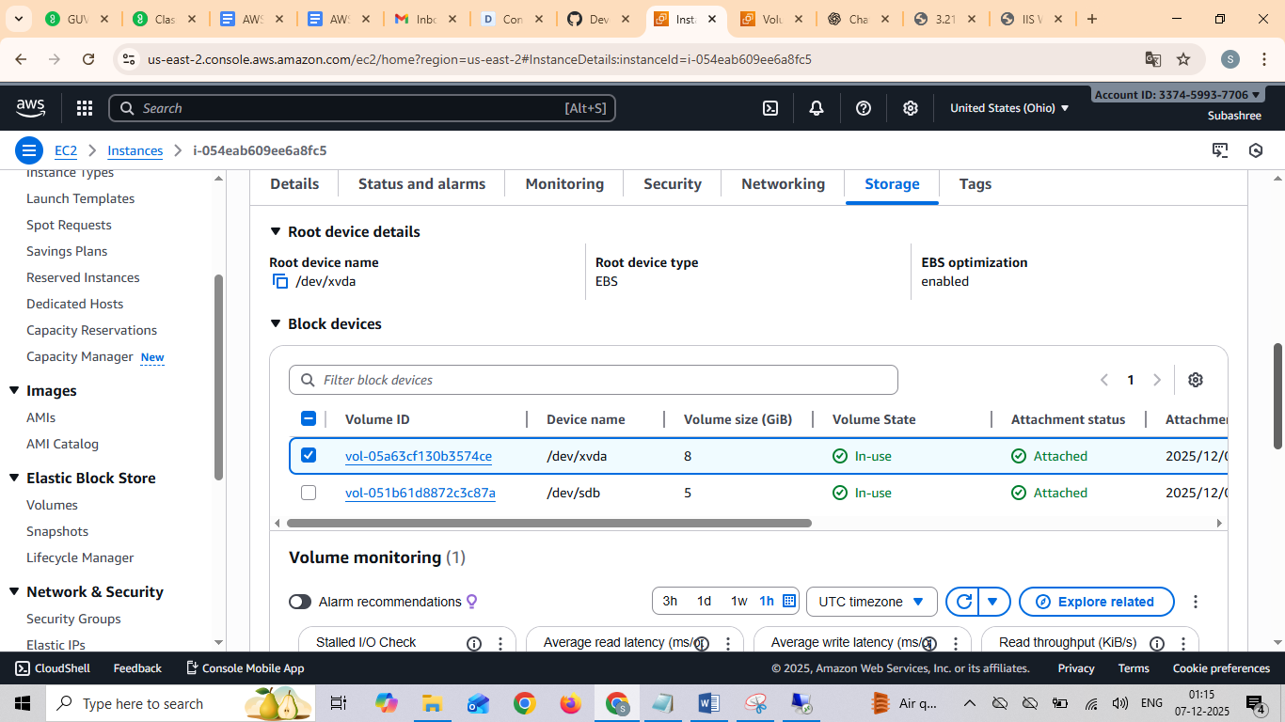

Added volume in linux instance

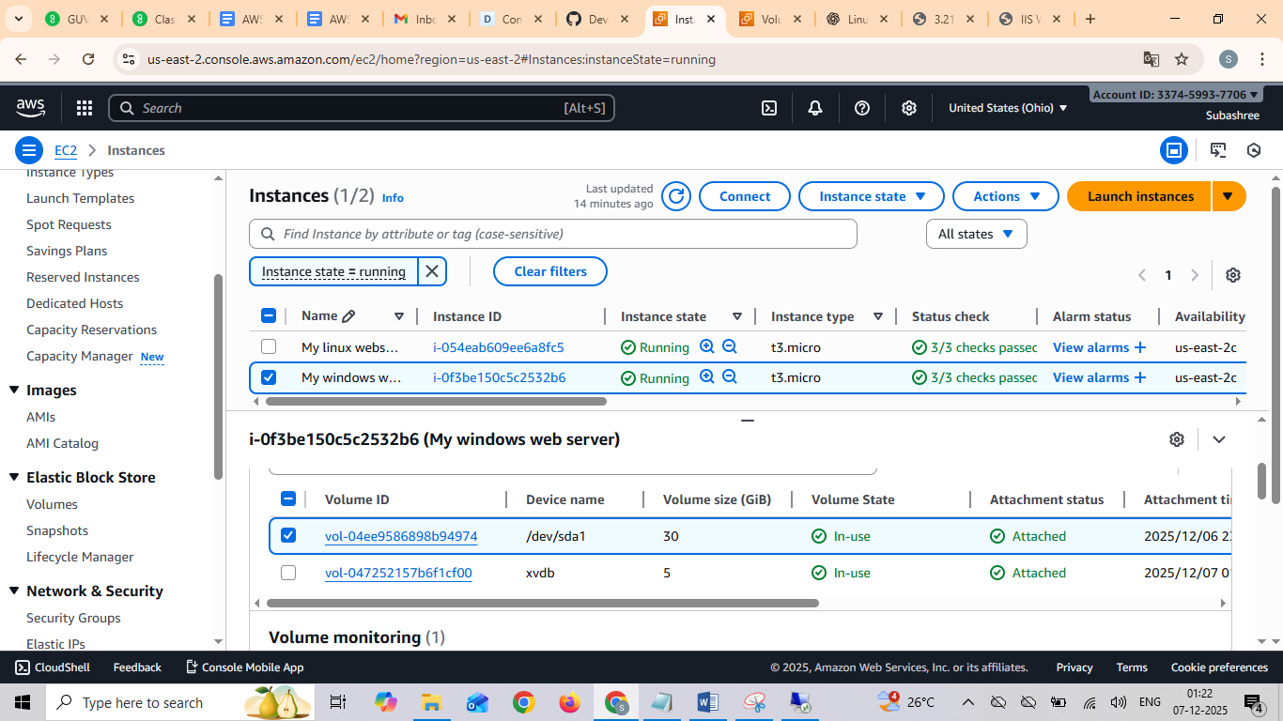

Added 5GB volumes for windows server

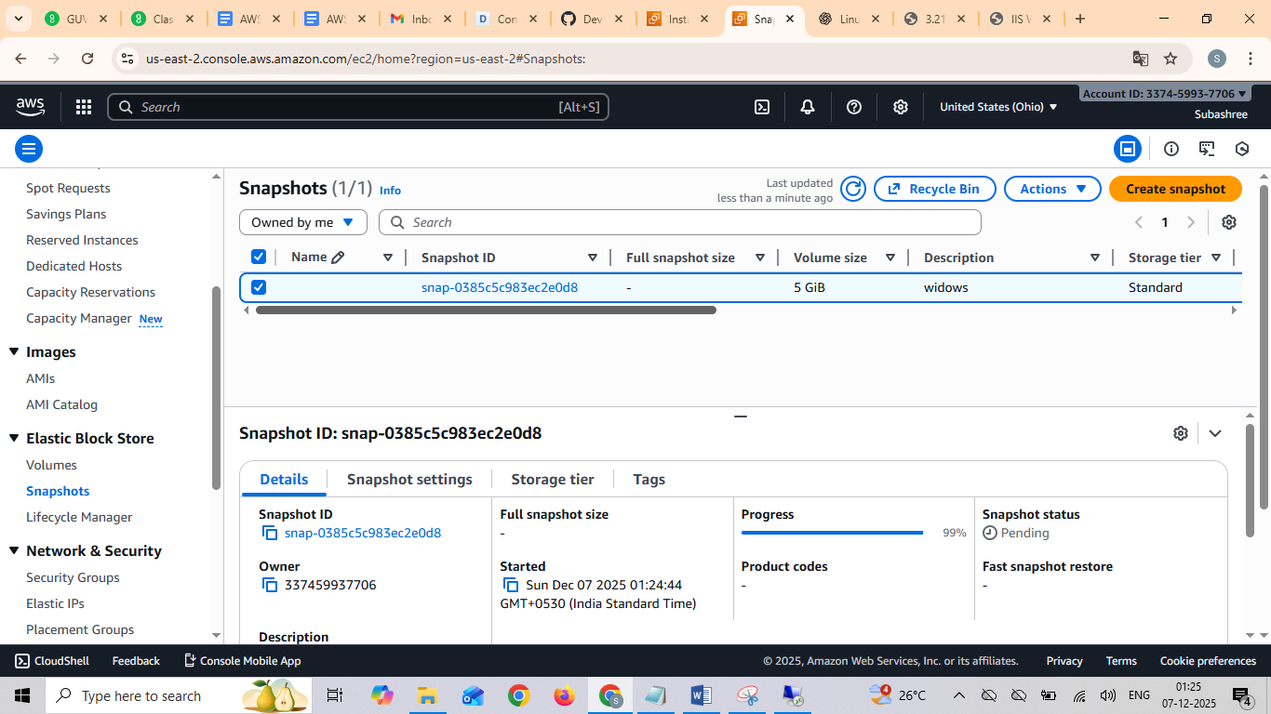
Created snapshot for windows

And then created volume from this snapshot to different region from 2c to 2b
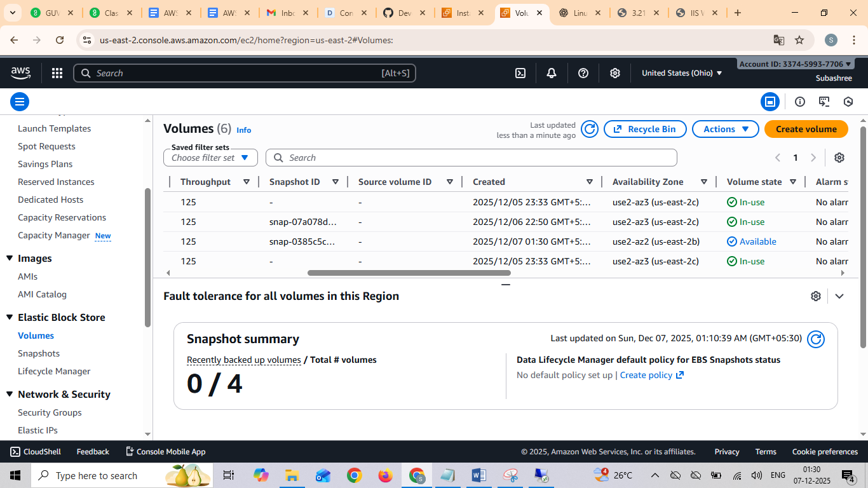

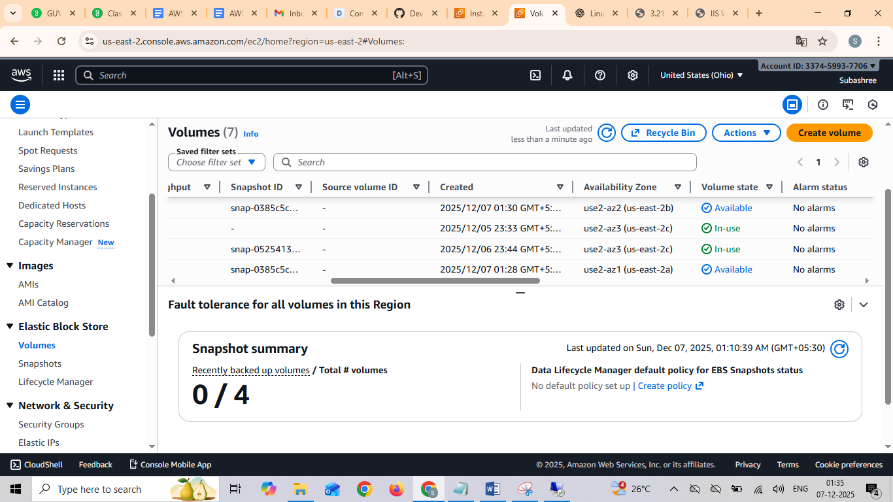

Created snapshot for linux and created a volume for 5GB

